OVERVIEW
--------
Snowflake offers a free 30-day trial with $400 in credits. No credit card is required
to sign up. This guide walks developers through activating and setting up a Snowflake
trial account.

STEP 1: SIGN UP FOR A TRIAL ACCOUNT
------------------------------------
1. Navigate to: https://signup.snowflake.com/?t=15df3eecadd1ecb1feb8b52de1bd89f13cf20010aa9ed66617d4db4546d4dcac

2. Fill in the registration form:
- First Name, Last Name
- Email Address (use your work email)
- Why are you signing up?
- Company Name
- Job Title

3. Select your preferred options:
- Snowflake Edition: Select "Enterprise" for full developer features
- Cloud Provider: AWS
- Region: US EAST (Northern Virginia)
4. Click "GET STARTED" / "Continue"
5. Check your email for an activation link from Snowflake.

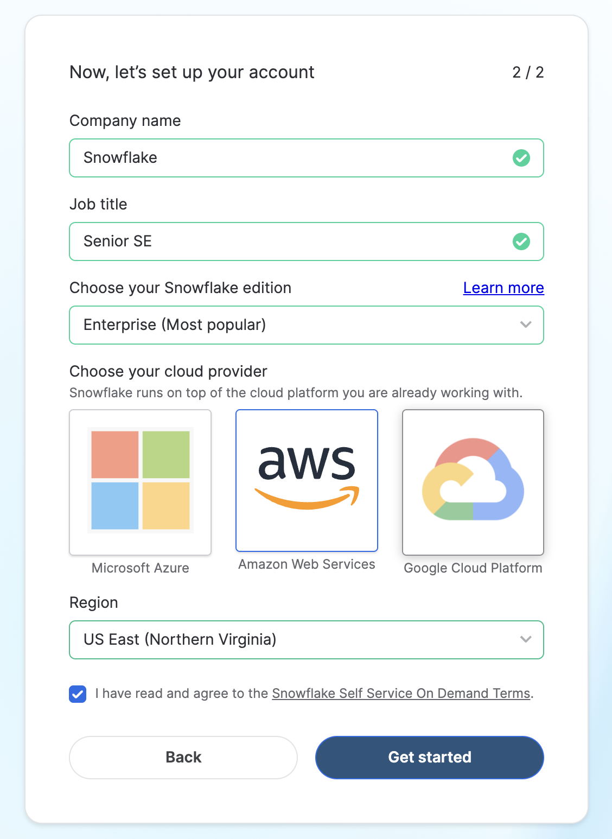
STEP 2: ACTIVATE YOUR ACCOUNT VIA EMAIL
-----------------------------------------
1. Open the activation email from Snowflake (subject: "Activate your Snowflake account").
2. Click the activation link in the email.
- Note: The activation link expires after 24 hours.
3. You will be redirected to a page to set your:
- Username
- Password (minimum 8 characters, must include uppercase, lowercase, number)
4. Click "Get Started" to complete activation.

STEP 3: LOG IN TO SNOWSIGHT (SNOWFLAKE UI)
-------------------------------------------
1. After activation, you will be redirected to Snowsight (the Snowflake web UI).
2. You are good to go with the Hands-on Lab

LINKS FOR HANDS ON LAB GUIDES

- Snowflake Intelligence HoL Guide: https://www.snowflake.com/en/developers/guides/from-zero-to-agents/
- Cortex Code HoL Guide:
https://www.snowflake.com/en/developers/guides/build-real-time-fraud-detection-model-with-natural-language-in-snowflake-ml/

Prompts for Cortex Code HoL Guide:

- Generate realistic looking synthetic data in database ML and schema PROJECTS
(create if it doesn't exist). Create a table Fraud_ML_TEST_ONLINE with 10000
financial transactions where ~0.5% of them are fraudulent. Include Amount,
Location, Merchant, and Time. Make the fraudulent ones look suspicious based
on location or amount, but add realistic noise: ~1/3 of fraud transactions
should have normal-looking patterns (typical amounts, common locations,
regular hours), and ~2% of legitimate transactions should have suspicious
characteristics (high amounts, unusual locations, or odd hours).

- Do exploratory data analysis and recommend the features needed to train a model that can predict fraud.

- Use features generated above to train a XGBoost machine learning model for
real-time fraud detection.

- Build a Streamlit application for real-time fraud detection monitoring
featuring three interactive tabs-Dashboard Overview, Real-Time Scoring, Model Performance

